|  |  |
| --- | --- |
| A picture of a winding road and trees  **WIT Hackathon Call-For-Code Entry** | Abstract  **ROADMAP to COVID 19 Solution: Fake NEWS Detector**  TEAM – Caffe-19  Team Members: Akansha Joshi  Prashasti Srivastava  Himangi Bansal  Kashish Mehta  Sindhura Nadella |

**INTRODUCTION:**

In the present age of social media we see multiple Bogus stories floating around, be it related to the COVID-19 pandemic, terror attacks or political vendetta. To ease the process of spotting fake news related to COVID19, we have designed a project to accurately classify a piece of news related to COVID19 as REAL and FAKE.

**TECHNOLOGY USED:**

* **Python (AI/ML)** - Using sklearn library, we built a Tf-idf Vectorizer on our dataset for Text Pre- processing. Then we initialized a Logistic Regression Classifier to fit the model. In the end the Confusion Matrix determined the accuracy score to identify the best algorithm out of Multinomial and Logistic Regression and created a output file to be used for flask app and to predict and label the data **.**
* **IBM Watson Studio for Jupyter Notebook –** We have used IBM Watson to launch the Jupyter Notebook in order to create Model file for our Project.
* **Web Framework Using Flask** – We have developed our Web Framework using Flask for Front-end. We have used HTML, CSS and Javascipt to enhance our GUI.
* **Git Repository –** Finally we have deployed our application on the GitHub repository.

Datasets Used – test.csv, train.csv, submit.csv and we have used Pandas dataframe to import our datasets to IBM Watson. Below is the flowchart for High Level representation of the Model:

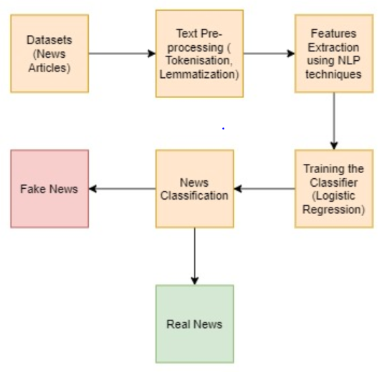

**ROADMAP FOR FUTURE** –

We will add on more functionality to check the origin of news whether it came from social networking site or from other platforms. We will include the functionality to allow readers to get rid of these fake news from their inbox.

For this, we can develop some high-level data analytics ability.

**The next steps for the Fake News Detector extension:**

### Short Term

* Small changes to make the extension usable and start marketing it to get early feedback .
* Allow users to check text for WhatsApp rumors.
* Sign in with Facebook to prevent cheating.
* Have a back-office area where journalists and other experts can help classify with safety most popular news.

### Medium Term

* Try to gather the most data as possible (by convincing a lot of people to use the extension and classify).
* Have a mobile app so users can also use the Fake News Detector on mobile (which is the major way people consume news now-a-days) by pasting the link on the app.

### Long Term

* Publicize it to journalists, fact checking websites and other important vehicles.
* Integrate with other tools, such as tracemap, hoaxanalyser, e-farsas, etc to give users better and more detailed results.